Quality Assurance Principles
SQA is committed to quality assuring all its qualifications to ensure public recognition and credibility through the maintenance of standards. SQA quality assurance is based upon the following principles:
♦The SQA assessment and quality assurance system should be understandable to stakeholders, effectively administered, publicly accountable and cost effective to operate
♦Qualifications should be accessible to all candidates who have the potential to achieve them
♦The criteria which define the performance required of candidates for them to achieve qualifications should be appropriate to purpose, explicit and in the public domain
♦Each unit, course and group award should be unique and necessary, and should comply with the relevant qualification specification
♦Assessments should be valid, reliable and practicable, and assessment results should be in line with qualification criteria
♦Qualifications should be offered in centers which have the resources and expertise to assess candidates against the qualification’s criteria
♦Staff in centers should be provided with effective support in assessing candidates for certification
♦Responsibility for quality assurance should be devolved to centers where this is consistent with the maintenance of national standards.

Quality Assurance Practices
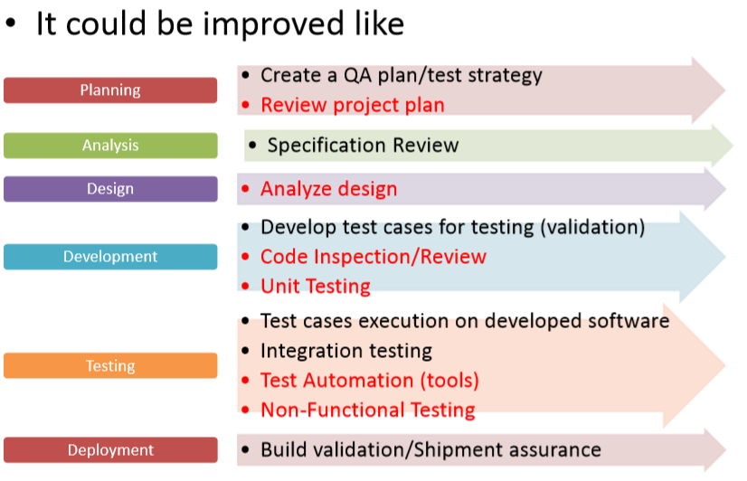
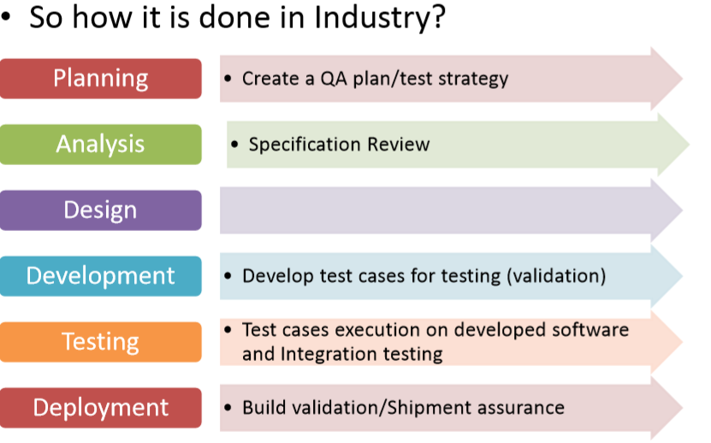
z

